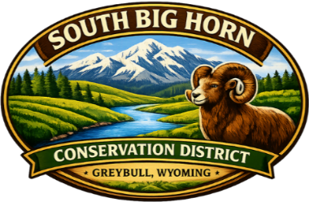

SOUTH BIG HORN CONSERVATION DISTRICT
April 7, 2026, AGENDA

Monthly Board Meeting Date: April 7, 2026
Meeting called by: George Kelso Starting Time: 4:00 P.M.
Desired outcome: Regular Business
Agency Reports
Chairman: George Kelso
Recorder-District Manager: Ashley Coenen
Group Members: George Kelso, Linda Hamilton, Howard Wildman, Eddie Johnson, Walter Hibbert, Laura Galloway; District Conservationist, Ashley Coenen; District Manager

Order of Agenda Items
Old Business:
Minutes Board Review & Approve
ADDITIONS AND/OR CORRECTIONS TO AGENDA
Treasurers Report District Manager Review & Approve
Checking Account***5307 $ 64,035.33
Tree Acct Checking***5343 $ 4,443.11
Tree Acct Savings***2184 $ 7,508.60
Reserve Account***7053 $ 19,148.40
Vouchers Board Review & Approve

NEW BUSINESS
Approval of April Bills
WID Updates
NRCS Report
Other Business
Office Report

MEETING ADJOURNED

